|  |  |  |
| --- | --- | --- |
| Sprint review - **increment three delivery** | | |
|  | | |
| **Location:** | Google Meets |  |
| **Date:** | October 20, 2020 |  |
| **Time:** | **6:00 PM** |  |
| **Facilitator:** | Baheshta Abed |  |

# Attendees:

Mashall Addeel, Sayed Manshour Sadat, Masuoma Tajik and Mahdi Alizada.

**Meeting Purpose:**

The purpose of this meeting was for the Development Team to present the third increment for the Product Owner to either approve or reject or give feedback for any changes.

**Below are the events that took place in the meeting:**

In the opening note, the Scrum Master briefly explained of the events that took place in the previous Sprint that lead to the finishing of this Increment, followed by the Development Team, presenting the project they have worked on, to the Product Owner.

During the Sprint, the Scrum Master did conduct Daily Sprints via Facebook Messenger, in order to keep a track of the tasks being done accurately based on the Product Owners’ demand (i.e. the user stories). Below are the Sprint Backlogs as well as the Burn Out Chart for the third Sprint.

Burn Out Chart

|  |  |  |  |  |  |
| --- | --- | --- | --- | --- | --- |
| **Tasks** | **Hours** | **Day 1** | **Day 2** | **Day 3** | **Day 4** |
| Implement a “Delete Option” for books | 4 | 4 |  |  |  |
| Allow “Add Option” to the Admin to add users in the Database | 4 | 2 | 2 |  |  |
| Design and create check-in and out of books through members whose data are in the database | 4 |  | 4 |  |  |
| Include option of “Genre” on Quick Search Option | 4 |  |  | 4 |  |
| Enhance the “Quick Search” Option | 4 |  |  | 2 | 2 |
| **Total Hours:** | **20** | **6** | **6** | **6** | **2** |



**Sprint Backlogs** were updated every day throughout the Sprint.

Day 3 of Sprint III

Day 2 of Sprint III

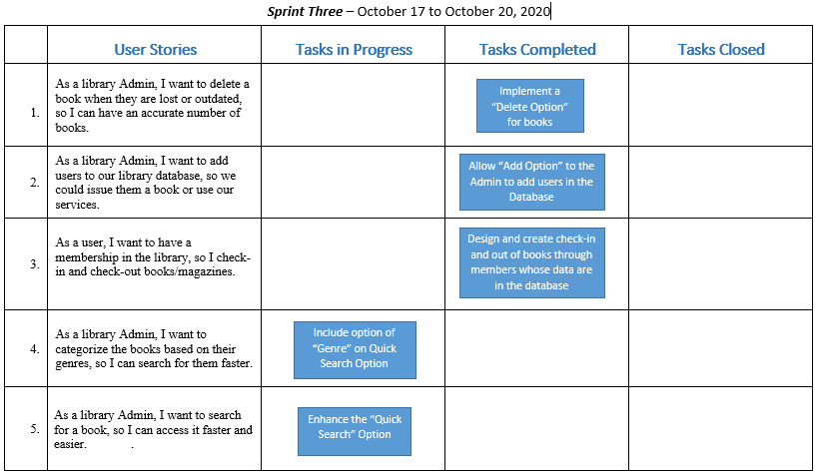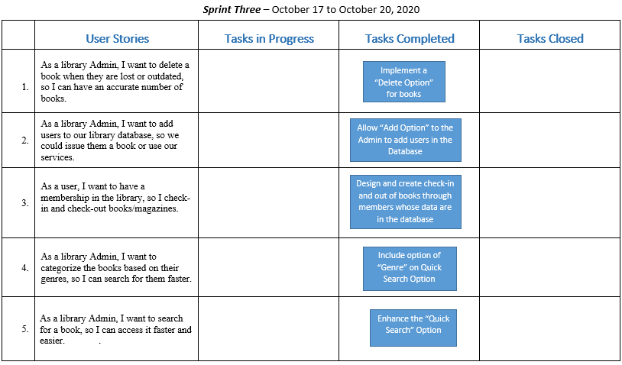

After the Development Team presented the project, the Product Owner was yet again satisfied with their work. However, the Product Owner did have some more comments as compared to the previous increments. The Development Team decided to work on comments and finish by the end of the day. The Product Owner mentioned that, that the Team can work on the comments and present it again in the final increment. Therefore, this increment too was a success, mostly for the reason that the Product Owner is on track with the process of the work of the Development Team and give comments on spot when she notices the team not on track. For this reason, the increments are a success so far. After the presentation was done, the Product Owner approved of the overall work and asked the Development Team to proceed with the net increment (i.e. Increment Four) and deliver it on October 24, 2020.